In-class Exercise

Submit the code and screenshot of the results in place of my screenshots

1. Create a PL/SQL anonymous block program unit that displays the sum of even numbers from 1 to 200. (30 Points)

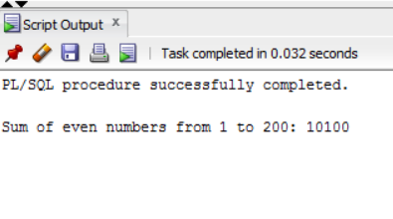

Write your code here:

“

set serveroutput on;

declare

total int;

count_loop int;

begin

count_loop := 0;

total := 0;

for count_loop in 1..200 loop

if mod(count_loop,2) = 0

then total := (total + count_loop);

end if;

end loop;

dbms_output.put_line('Sum: ' || total);

end;”

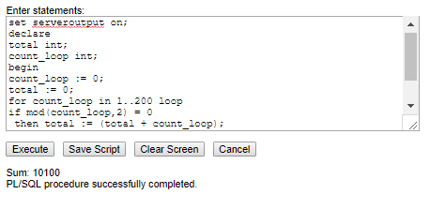

1. Create a PL/SQL anonymous block program unit that displays the VENDOR_NAME and VENDOR_STATE for the VENDOR whose VENDOR_ID is 93. (30 Points)

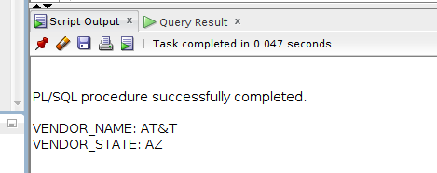

Write your code here:

“declare

vendor_name_text vendors.vendor_name%type;

vendor_state_text vendors.vendor_state%type;

begin

select vendor_name, vendor_state

into vendor_name_text, vendor_state_text

from vendors

where vendor_id = 93;

dbms_output.put_line(Vendor_name_text);

dbms_output.put_line(Vendor_state_text);

end;”

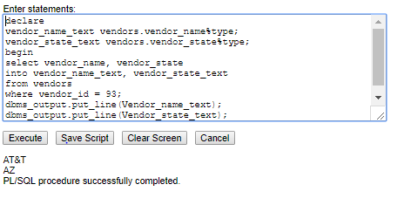

1. Create a PL/SQL anonymous block program unit that displays the VENDOR NAME, ADDRESS1 and CITY for all the VENDORS in Illinois STATE (‘IL’). (40 Points)

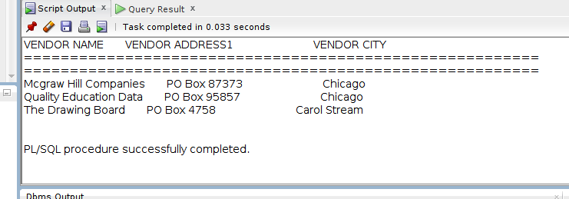

Write your code here:

“declare

cursor vendor_cursor is

select vendor_name, vendor_address1, vendor_city

from vendors

where vendor_state = ('IL');

v_row vendor_cursor%rowtype;

begin

open vendor_cursor;

loop

fetch vendor_cursor into v_row;

exit when

vendor_cursor%notfound;

dbms_output.put_line(v_row.vendor_name ||' '|| v_row.vendor_address1||'

'|| v_row.vendor_city);

end loop;

close vendor_cursor;

end;”

